June 13, 2022

Dear SGJH families,

I couldn’t let the year end without making sure all of you know about some of the exceptional things going on in our school.

We have implemented some new literacy tools this year and I am very pleased to report that we are already seeing measurable improvements in our students’ reading and writing skills. We have dedicated language teachers who are focused on bringing our instruction up to the peak of educational standards. Watch for a parent meeting in the fall, where we will explain more about how we assess and address literacy needs so every child can grow.

I am constantly impressed with the variety of option classes our small school is able to provide. Thanks to the willingness of staff members to share their expertise, we have been able to offer:
Drama, Hunter’s Education, Coding, French, Guitar, Creative Writing, Soapmaking, Business, Cultural Arts, Spanish, Painting, Native Dance, Native Studies (including Blackfoot language), Fishing, Foods, Band, Green Screen Movie Making, Mechanics, Construction, Archery, Fitness, Hiking, and Photography. I don’t know of any school our size who is able to give students exposure to such a range of experiences at this stage of their lives. I know of many larger schools who don’t. It is truly an aspect where our school shines.

On that note, I am very happy to report that we have received approval from the Division to convert one of our existing storage sheds into a workshop space, with electricity, heat, and water. This is the first step in a long-anticipated plan to offer entry level trade experience to our students. We have already begun some basic carpentry, and will now be able to expand that further. We have received $9,000 from the Community Foundation of Lethbridge and $3000 from Nutrients for Life which will fund the construction of our workshop and a greenhouse at the school. This is just the beginning of what I hope will be a robust early trades program.

Our manners initiative focused on “52 Modern Manners for Today’s Teens” has been a meaningful addition to our school culture. Increased respect for self, peers, and community is the goal. As a reminder, please let us know if you would like a copy of the book in your home, and we may be able to do a bulk purchase.

Once again, thank you for supporting your student throughout the school year. If you ever have concerns about anything here at the school please do not hesitate to contact me. My purpose is to help every student have a great school year.

Sincerely,

Mr. Jamie Barfuss
Principal

P.S. Please see the reverse for details on the next several days.

LAST WEEK OF SCHOOL:

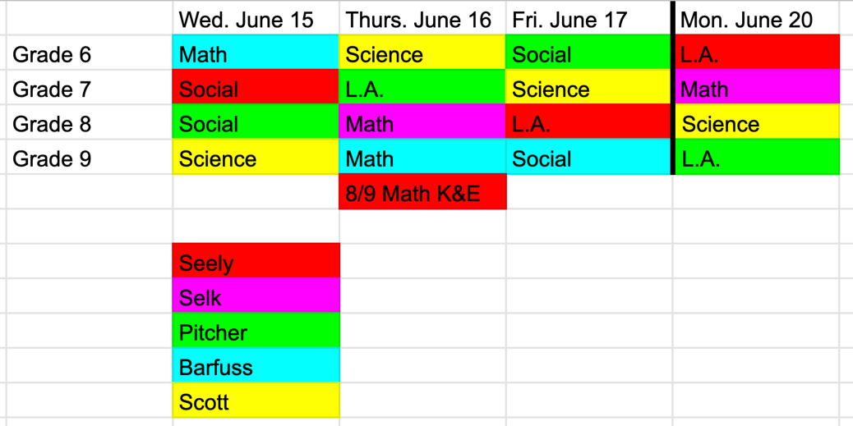
Exams: We have dedicated large amounts of time to review in the last few weeks. I hope students feel prepared for their tests. The best thing they can do at home this week is to eat and sleep well. Each exam will begin in the morning as soon as students are settled. They are free to go home after they are finished writing. Please plan to pick them up or inform the office if they have permission to leave independently. Students who stay through the afternoon will be supervised by the teacher administering the next day’s test, enabling them to do more study and review.

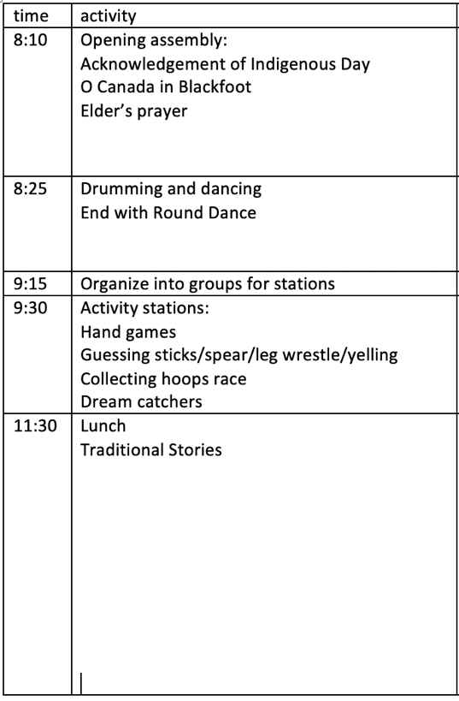
Indigenous Day: On Tuesday, June 21 we are holding for the first time a mini powwow, with indigenous games, crafts, and activities. Lunch will also be provided for all students. The Hope Squad planned it with much support from Mr. First Charger and we anticipate a really fun and meaningful day. All families are encouraged to join us for any part of the day.

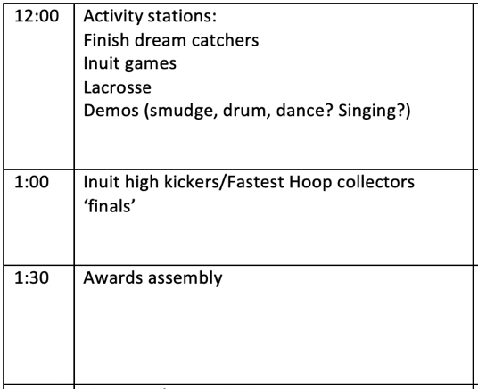
Awards assembly: At 1:30 Tuesday afternoon (right after our Indigenous Day activities) those students in grades 6-8 who have earned academic or athletic awards will have them presented. Families are welcome to stay for this as well.

Grade 9 graduation: Also on Tuesday, our Grade 9 students will have their graduation ceremony, including their awards presentation. This will be at 6:30 pm in the school gym. No tickets are required and anyone who would like to may come.

Last Day of School: Wednesday, June 22 we will be spending the day in Waterton. Students should come prepared for a hike, with their bagged lunch. Once again any family members are welcome to join us.

Report cards will be mailed out Friday June 24.

